# Creating AWS Database using Terraform

# Steps

# Makedir

# Make 2 Files

* **Main.tf**
* **variables.tf**

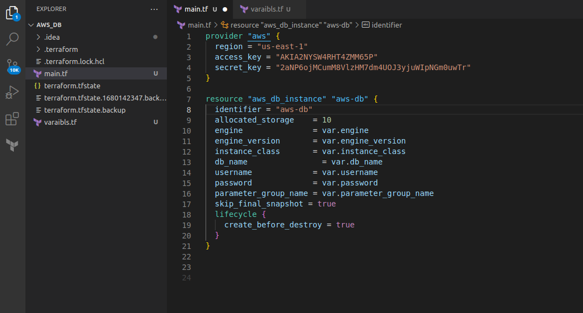

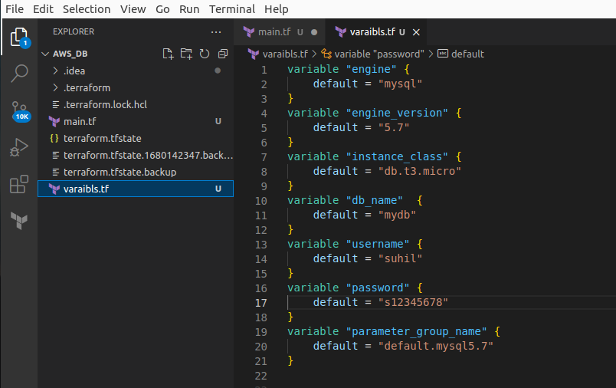

# Create database configuration file

* **Init**
* **Plan**
* **Apply**
* **creating**

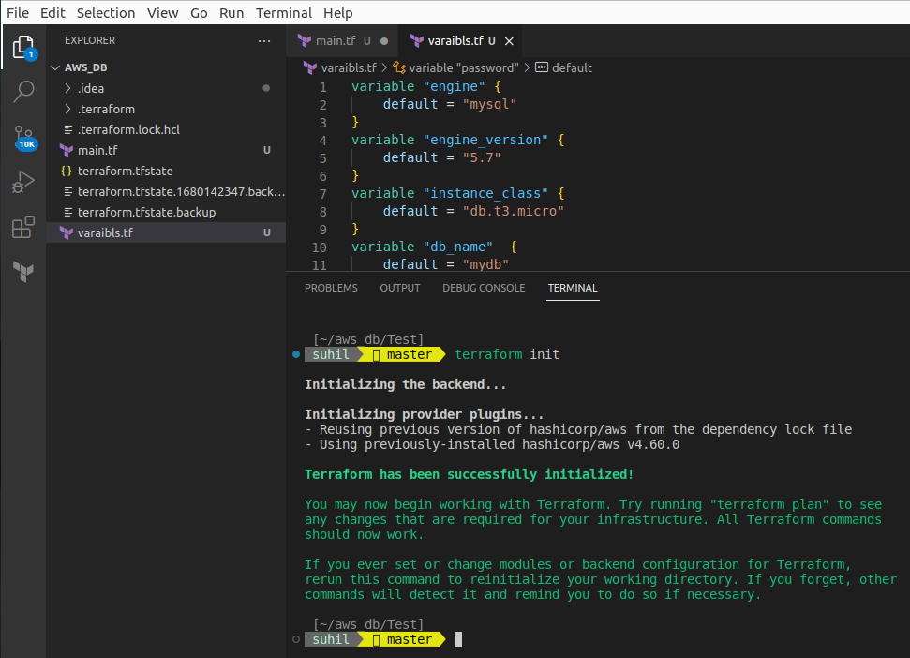

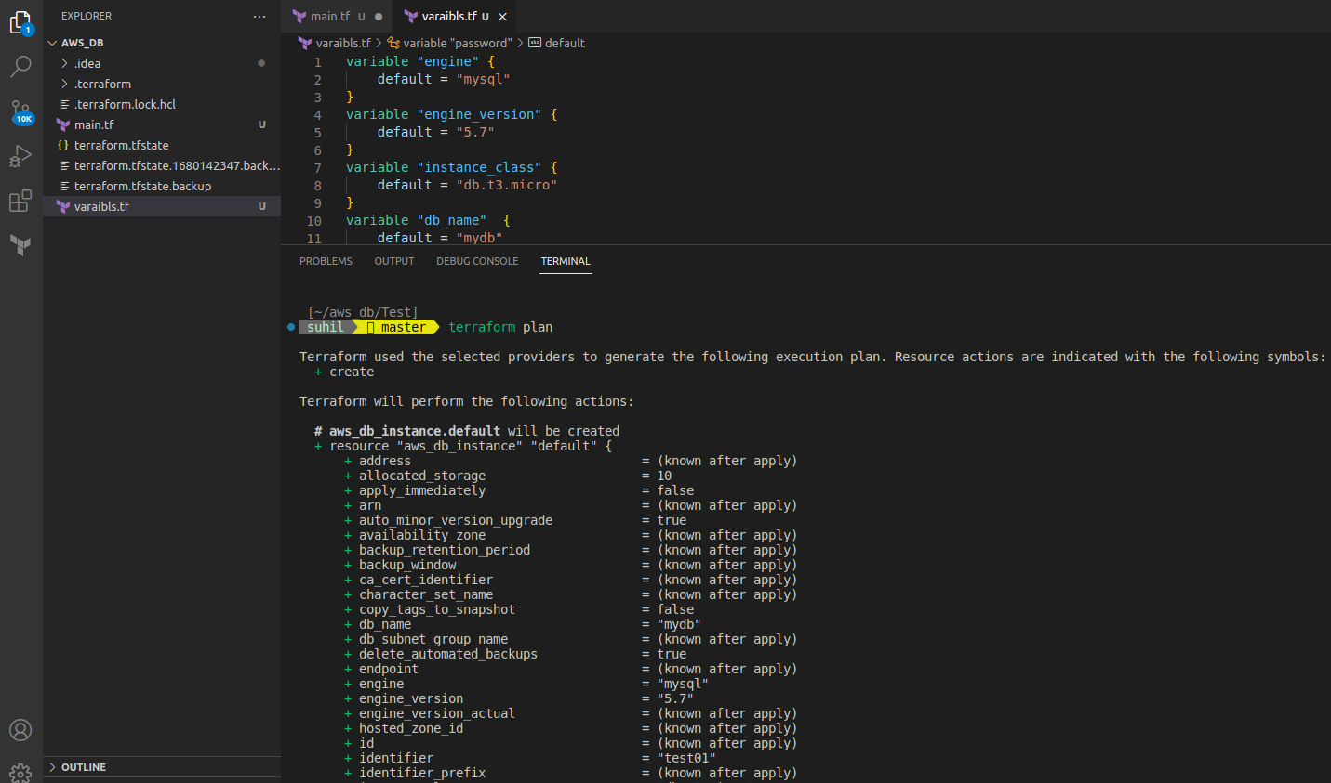

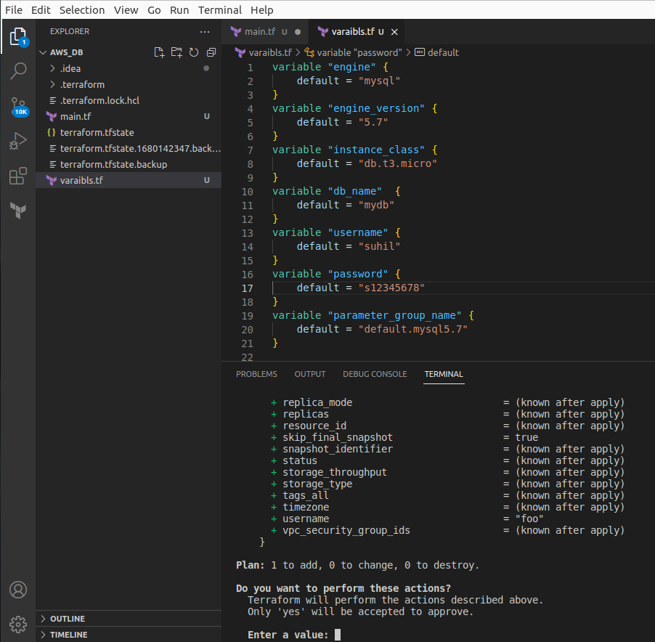

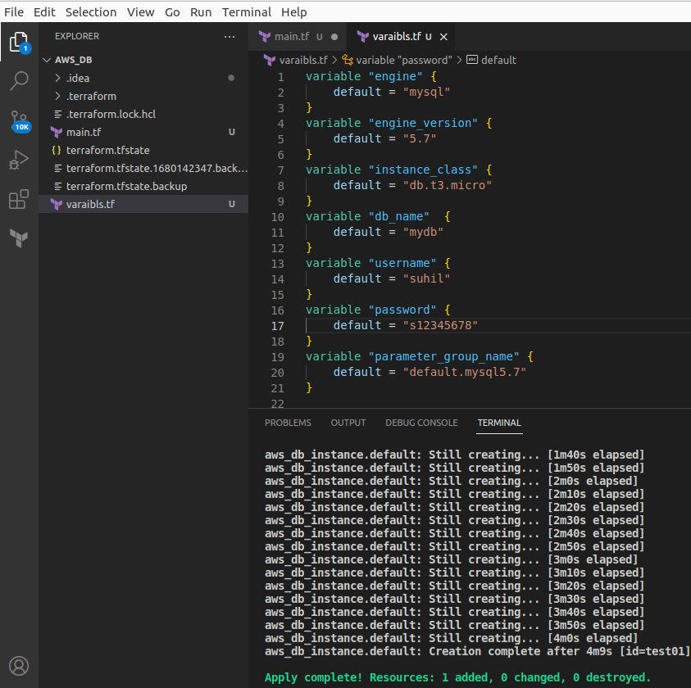

# Show Database in real time

